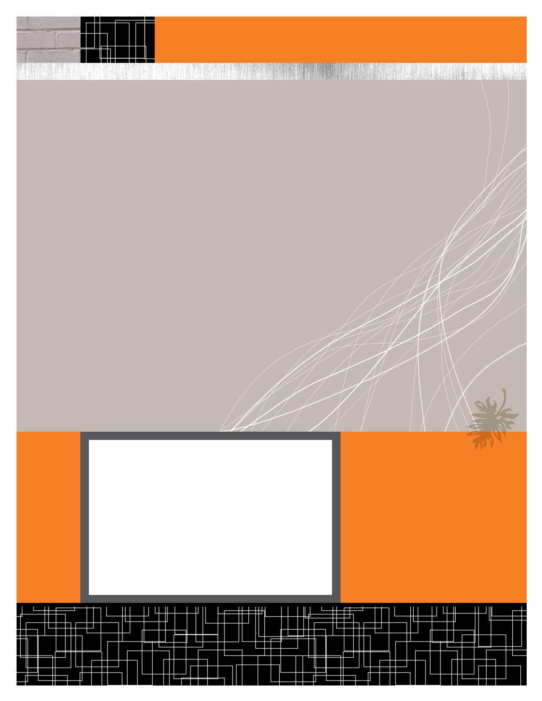

Anshul Jain (Y09UC027)

Mumal Seth (Y09UC086)

Shreya Mundra (Y09UC150)

Karan Poddar (Y09UC301)

Course Registration Portal

Class Diagrams

March 19 , 2012

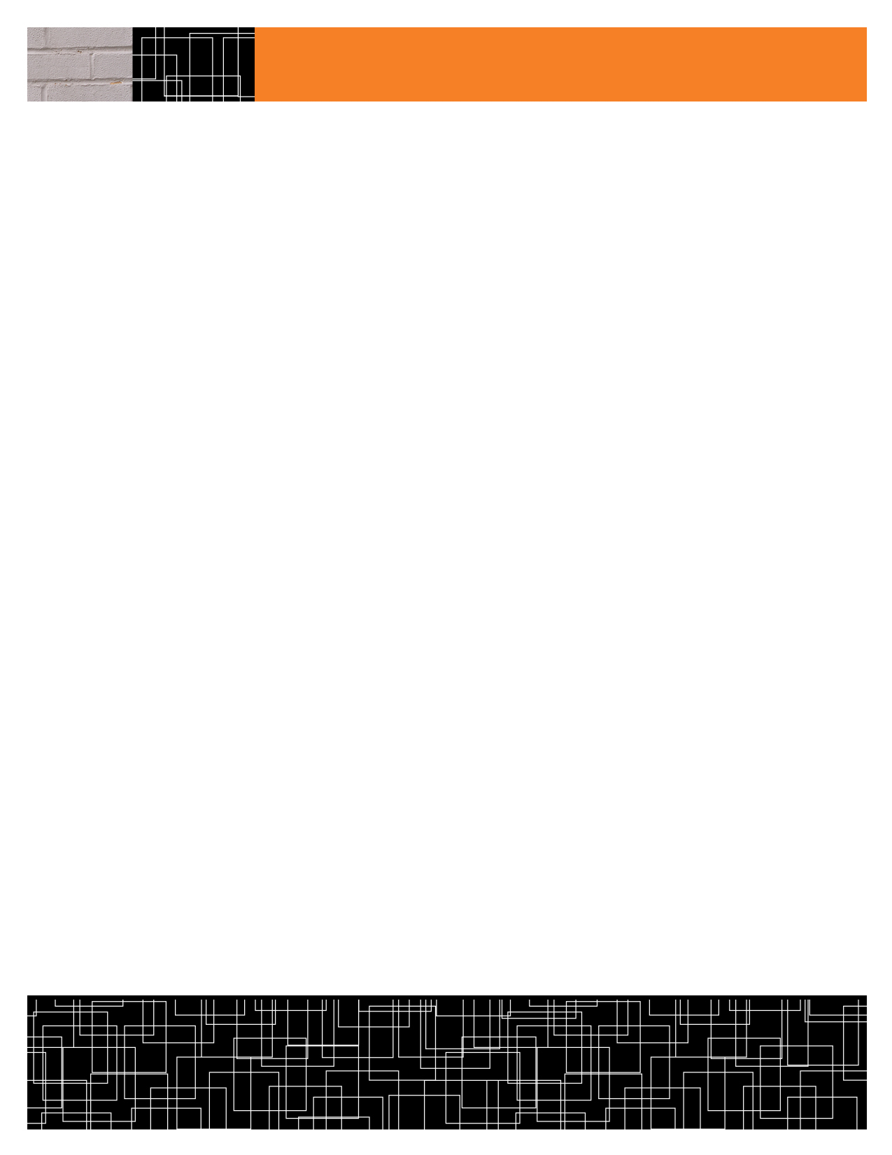

addCourse()

modifyCourse()

deleteCourse()

viewCourseDetails()

CourseId : String

FacultyId : String

CourseName : String

addDropFlag : Boolean

RegistrationFlag : Boolean

normalRegistration()

specialRegistration()

overloadRegistration()

generateApplication()

dropCourse()

**courseAllocation()**

StaffID: String

DeanID: String

startEvent()

endEvent()

Event : String

startTime : Time

endTime : Time

**Events**

**Course**

**Registration**

**UserLogin**

UserName: String

Password: password

Login ()

getPRStudentList()

approvePR()

**Academic Staff**

getPRStudentList()

viewApplications()

viewStudentProfile()

viewCurrentSemCourses()

applicationApproval()

**Dean**

viewProfile()

getEnrolledStudentList()

FacultyId: String

CourseId: String

**Faculty**

viewProfile()

swapCourse()

**Student**

Roll no. : String

PRFlag : Boolean

*PR : Physically Registered

CLASSES

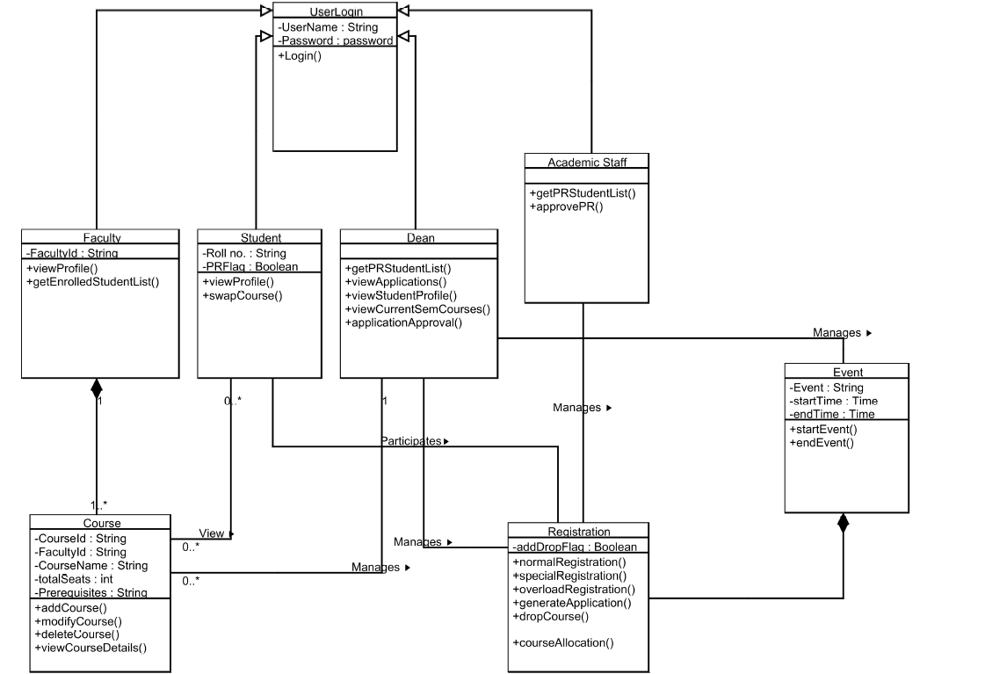

CLASS DIAGRAM